**Algorithm to count distinct element in an array**

Step 1: start

Step 2: Declare and input the array elements.

Step 3: READ array

Step 4: Traverse the array from the beginning.

Check if the current element is found in the array again.

If it is found, then do not print that element.

Else, print that element and continue.

Step 5: repeat step 4 for all the elements a of array

Step 6: stop

**FLOW CHART:**

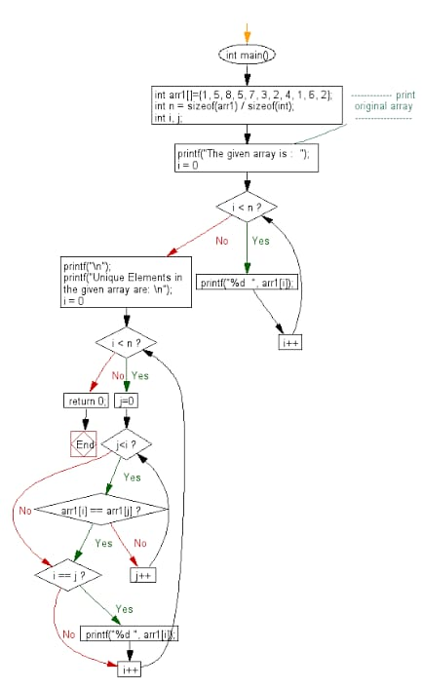

**PROGRAM :**

#include <stdio.h>

void distict_elements(int a[], int n);

int main()

{

int size_array, i, arr[20];

scanf("%d", &size_array);

for(i=0; i<size_array; i++)

{

scanf("%d", &arr[i]);

}

distict_elements(arr, size_array);

return 0;

}

void distict_elements(int a[], int n)

{

int i, j;

for (i=0; i<n; i++)

{

for (j=0; j<i; j++)

{

if (a[i] == a[j])

break;

}

if (i == j)

printf("%d ", a[i]);

}

}